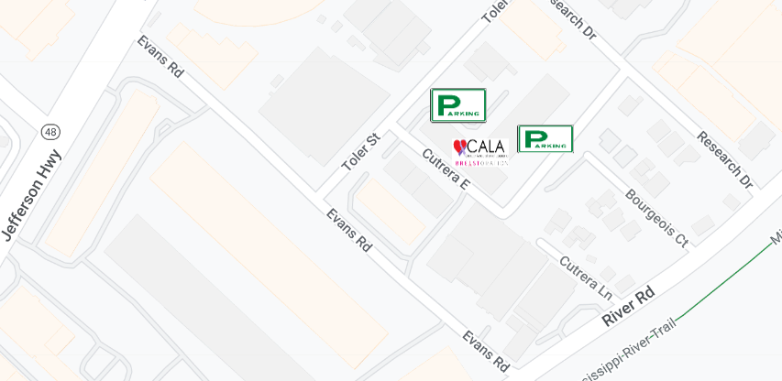
From Jefferson Highway  - Turn onto Evans Road  - Take a left onto Toler St  - Take your first right into the parking lot on Cutrera (You’ll see a UPS Pickup box)  - Take your first left to the parking lot behind building 3 | From River Road  - Turn onto Evans Road  - Take a right onto Toler St  - Take your first right into the parking lot on Cutrera (You’ll see a UPS Pickup box)  - Take your first left to the parking lot behind building 3  --OR--  - Turn onto Research Drive  Take your first left onto Cutrera and park in one of the unlabeled spots along building 4

